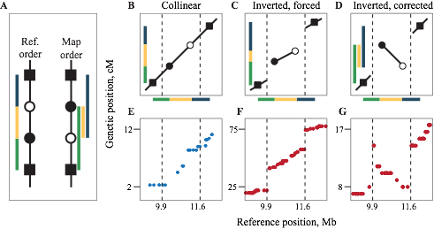

**Figure S1. Reference-guided genetic map construction allows identification and correction of chromosomal inversions.** A: Inversion polymorphisms create discrepancies between the reference physical genome and a genetic map. Colored bars indicate true map distances between genetic markers inside and on either side of the inversion. B: When the physical and genetic maps are collinear, map distances agree with the reference. C: An inverted genetic map forced into reference order results in a disjunct genetic map because crossover frequencies between markers inside and outside the inversion are inferred correctly. Note that the green and blue bars reflect the true distances between the markers involved but they are in the wrong order. D: Reversing the order of markers within the inversion preserved the relative map distances and reduced the overall map length. E-G: Genetic maps from the BT fish (E, collinear with reference) and the RS fish (F and G, inverted relative to reference) demonstrate this correction using empirical data.



**Figure S2. Effects of population subdivision linked genetic variation.** All simulations were run as in the main text, Figure 4: s = 0.20; m = 1 migrant/generation; 20NH generations of selection.



**Figure S3. Genetic maps for all 21 threespine stickleback chromosomes.** Genetic position for each RAD marker is plotted against aligned physical position on the threespine stickleback reference genome. Boot Lake: dark blue; Boot Lake, subset of 94 progeny: blue; Rabbit Slough: red; F1 hybrid: gray; F1 hybrid, subset of 94 progeny: black.



**Figure S4. Genetic divergence comprises a smaller proportion of the genetic map than the physical map.** Each line represents the proportion of the overall map lengths (Mb or cM) taken up by windows of genetic divergence (FST or dXY) greater than or equal to a given value. Gray: physical map; blue: Boot Lake genetic map; black: F1 hybrid genetic map.

**Figure S5. Window-based estimates of recombination rate (cM/Mb) and sequence diversity using (top) 100-kb non-overlapping windows and (bottom) 1-Mb non-overlapping windows.** Note the difference in axis scale with different window sizes.

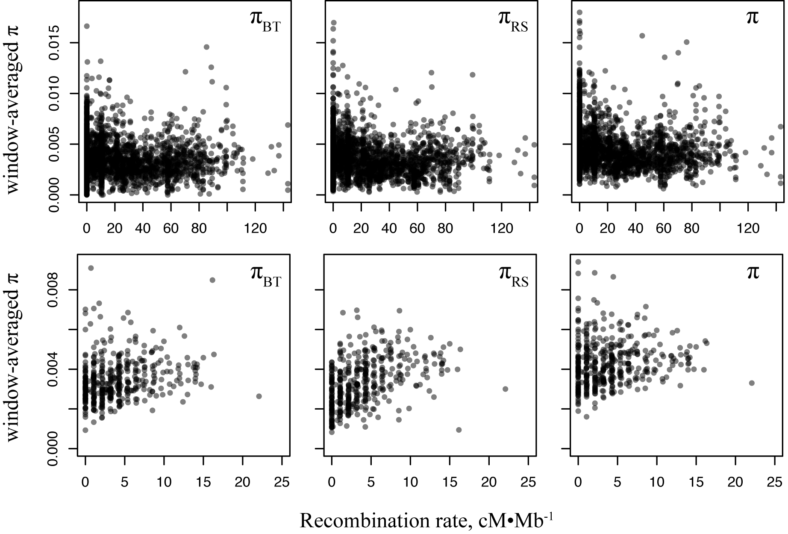

**Figure S6. Variation in recombination rate and covariation with population genetic statistics at different genomic window sizes.** All points are genome-wide summaries of recombination rate (cM/Mb) and correlation (as Spearman’s ρ) with population genetic variation and differentiation at a given window size using non-overlapping genomic windows. SD: standard deviation; π: sequence diversity; FST: differentiation between Rabbit Slough and Boot Lake populations.

